**I am new user, what should I do?**

1. Create Site

Site is where your farm is located. Before starting another activity, you have to create Site data first. Steps to add Site explained *here*

1. Create Flock

After creating the site, you can add a cage (flock) at the site. Steps to add Flock explained *here*

1. Start Cycle

Cycle is a period of raising chicken from DOC received at site to the harvest time. After adding a flock at a certain site, you can start the production cycle. By starting the cycle, you can record the production plan. Steps to start cycle explained *here*

1. Setting Production Standard

Production standards are the standard value to measure chicken production in a cycle. Production standard including body weight, FCR, Water and Vitality. When daily input is higher/ lower than standard, we will inform the problem to you at **Dashboard**. You can add/ edit provided default standards, so you can adjust the standard to meet your expectations. Steps to edit or add standard explained *here*

1. Activity Input

Input is a daily recording of your chicken production. You can record feed, water, mortality, average weight, disease, litter additive and harvest in input. You can record input daily based on activity happening at the farm. This data will be shown at the Production Cycle dashboard, input data will also be compared to standard value. This feature can be accessed in the **Input Your Activity** menu. Steps to add daily input explained *here*

1. Dashboard

Dashboard is the latest report about chicken production inside farms. You can see problems happening on the farm at Dashboard. Explanation about dashboard *here*

1. Report

Report is a summary of your production activity. There are 3 types of report: cycle report, interval report, and Input by type report. You can download the report in PDF format. Steps to generate report explained *here*

1. End Cycle

At the end of your chicken rising period, you can end the activity by performing an end cycle. When you end the cycle, you can generate a Cycle report in the Report menu. You can start a new cycle after ending the current cycle. If your cycle is supposed to end but you did not perform an end cycle, your cycle will automatically end. Steps to end cycle explained *here*

### Add Site

Here are steps to add Site:

* Go to **Manage Your Farm** menu, click **Add Site**

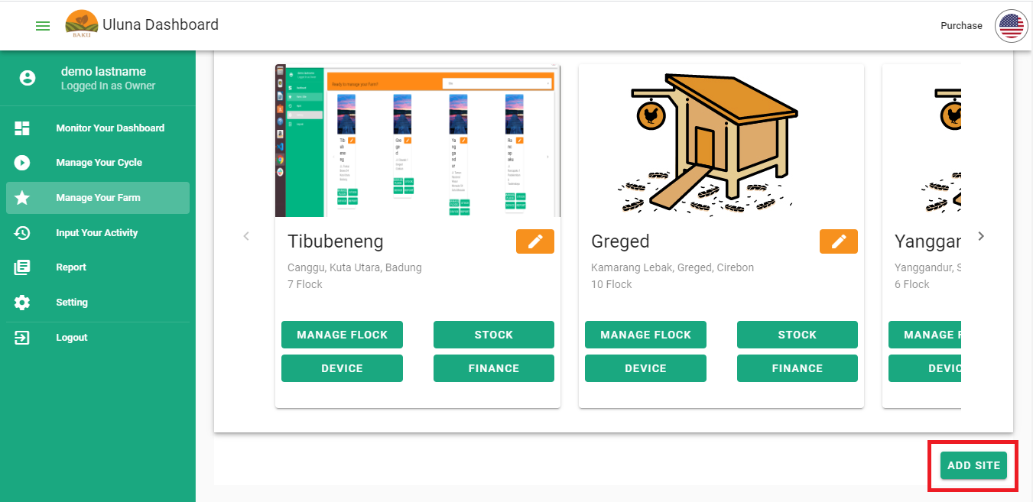

* Add location dialogue will open. In this dialogue you will be asked to input information about **Address**, **Site Name**, **Farm Photo**, **Electricity Capacity** and **Water Source**
* After finished input all information, click **Submit**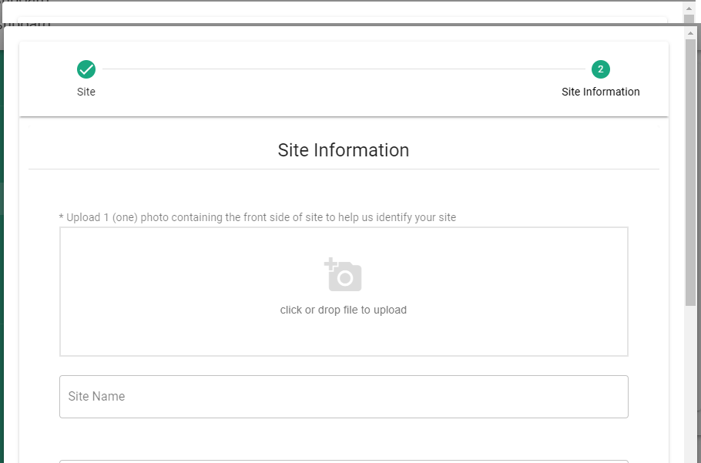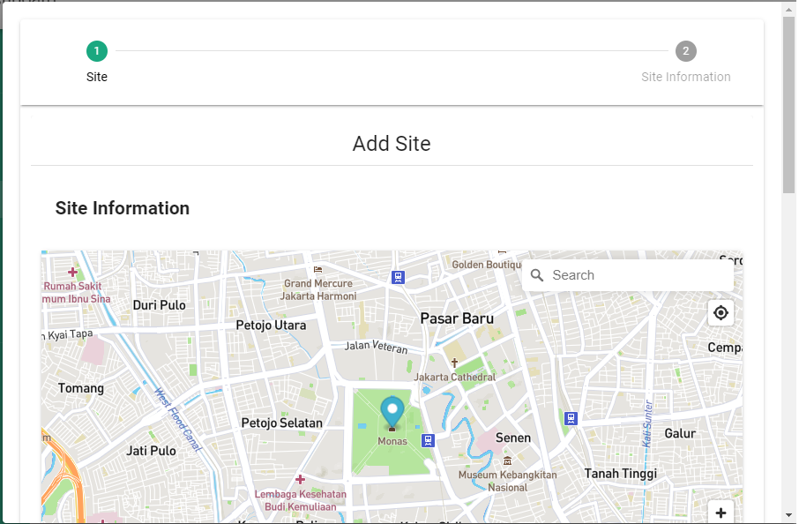
* Added Site will show at the page

### Edit Site

Here are steps to edit Site:

* Open **Manage your Farm** menu
* Choose Site you want to edit
* Click pencil button (✎) on the site

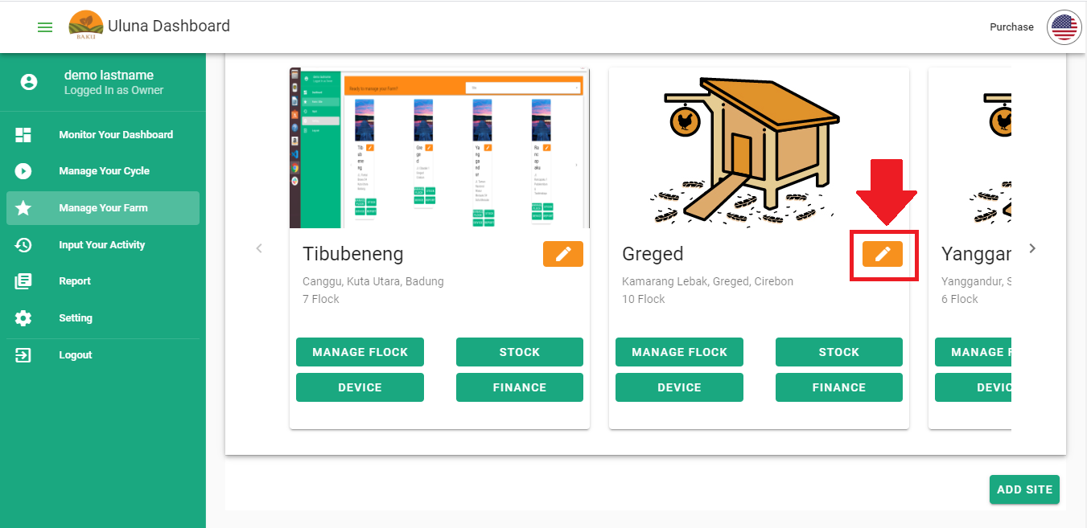

* Edit dialogue will open. You can edit **Address**, **Site Name**, **Farm Photo**, **Electricity Capacity** and **Water Source**. After you finish editing, click **Submit**

### Add Flock

Here are steps to add flock:

* Open **Manage your Farm**  menu
* Choose Site you want to edit
* Click **Manage Farm** button on the site

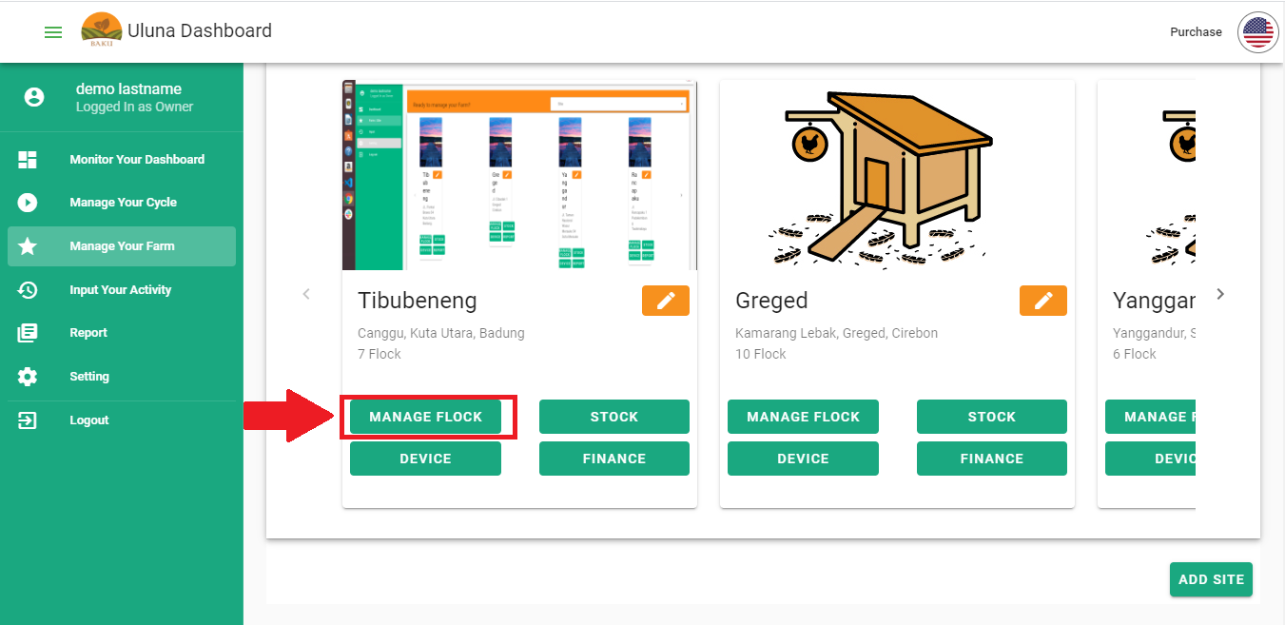

* Manage Farm page will open. Click **Add Flock**

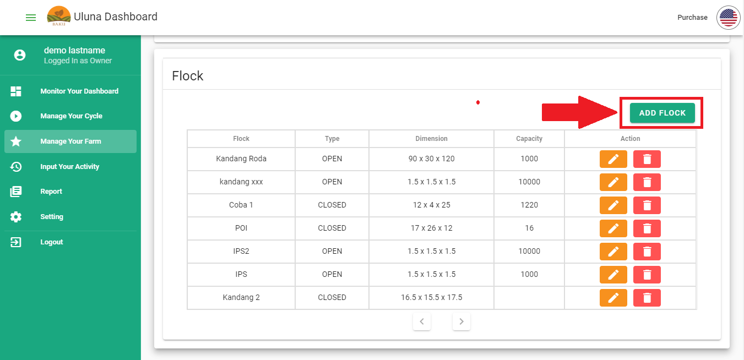

* Add Flock dialogue will open. You will be asked to input information about **Total Flock, Flock Name, Flock Type** (Open/ Closed), **Capacity** (in bird) and **Flock dimension** (length, height and width in meter). After finish input all data, click **Next**

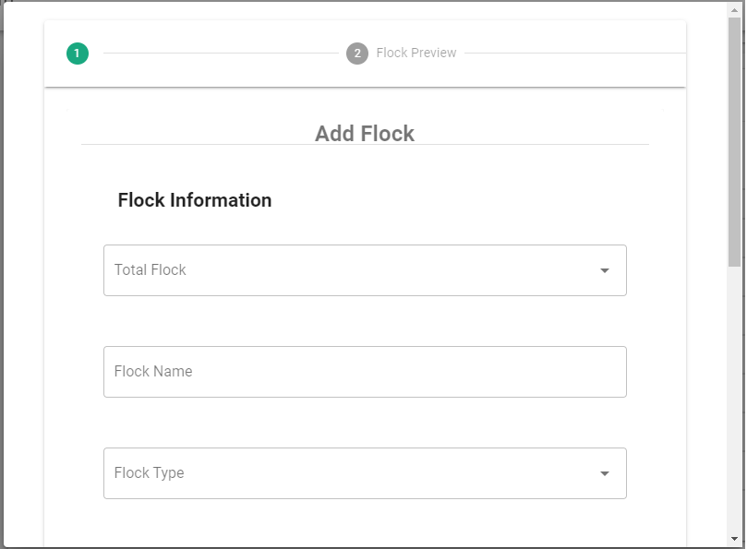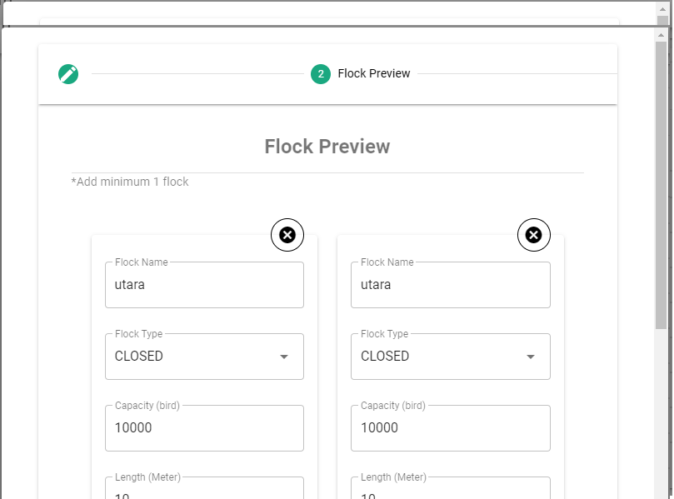

* You will see **Flock preview** dialogue. In Flock Preview you can check flock information before you proceeding to create it. You can input different name to identify each flock. If you are sure about the data, click **Submit**

### Edit Flock

Here are steps to add flock:

* Open **Manage your Farm**  menu
* Choose Site you want to edit
* Click **Manage Farm** button on the site
* Manage Farm page will open. Click pencil button (✎) on flock you want to edit

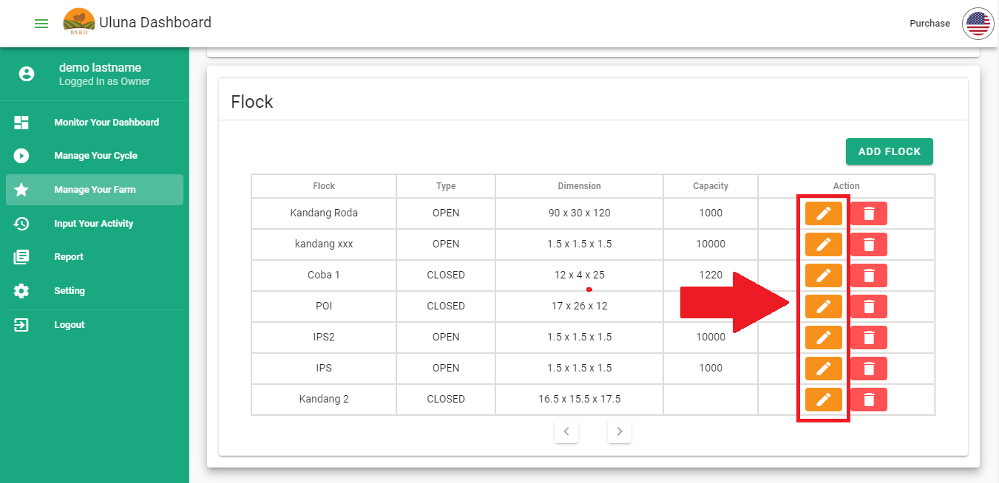

* Edit dialogue will open; you can edit flock data in this dialogue. After you finished editing, click **Submit**

### Delete Flock

Here are steps to delete flock:

* Open **Manage your Farm**  menu
* Choose Site you want to edit
* Click **Manage Farm** button on the site
* Manage Farm page will open. Click trash can button (🗑️ ) on the flock you want to delete. You can delete flock without cycle history. If the flock is currently active (has running cycle) or already finished at least one cycle, you can’t delete the flock.
* Warning dialogue as seen below will show, click **Confirm**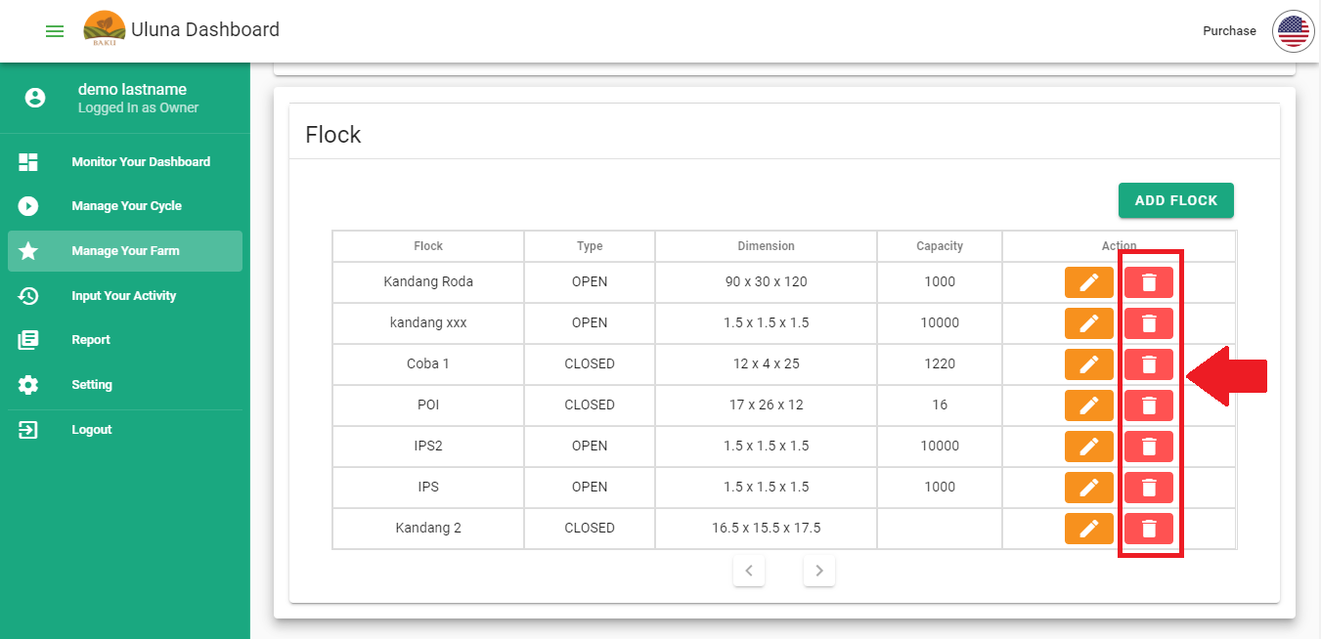

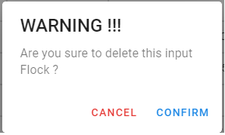

### Start Cycle

Here are steps to start a cycle:

* Open **Manage Your Cycle** menu
* Choose Site and Flock you want to start cycle
* Click **Start Cycle** button

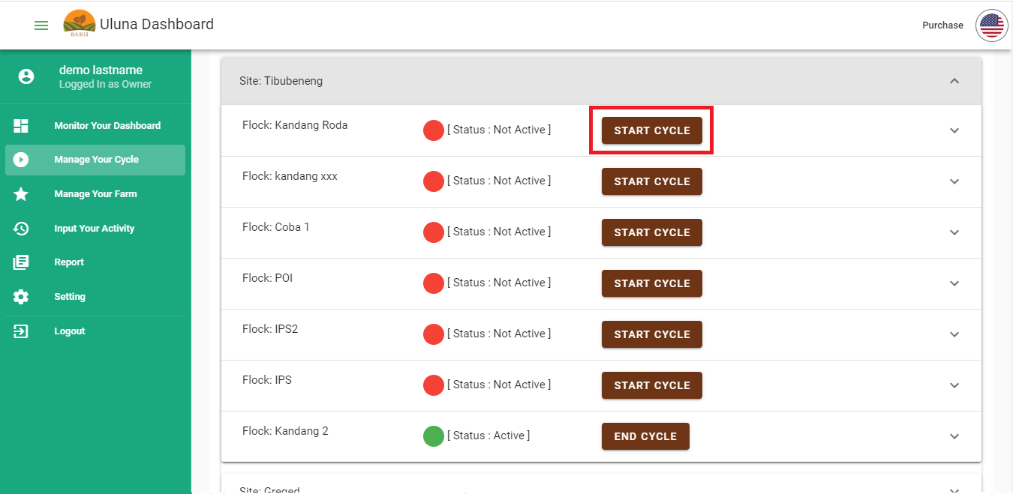

* Start Cycle dialogue will show, you will be asked to input these information:
  + ***Voucher:*** you should own a voucher before you start a cycle. For new user, you will get 1 free voucher for 40 days. You can purchase voucher in **Purchase** menu.
  + ***Start Date:***date and time when you start the cycle
  + ***Estimated harvest age:***estimated production period, from DOC to harvest.
  + ***Cycle Name:***to differentiate one cycle, give specific name to the cycle. You can name it by date, staff name or other identification
  + ***DOC Type:***Strain of DOC used in the cycle. DOC type will affect standard use. If you can’t identify the DOC strain, look at the DOC box/ package or ask the supplier. DOC type will affect the standard value that we will recommend to you, that’s why it’s critical to input the right strain.
  + ***DOC population:*** DOC population for current cycle
  + ***DOC price per bird:*** DOC price per bird (unit in Rupiah). This data will be calculated in Finance for the cycle report.
* After you input all data, click **Submit**

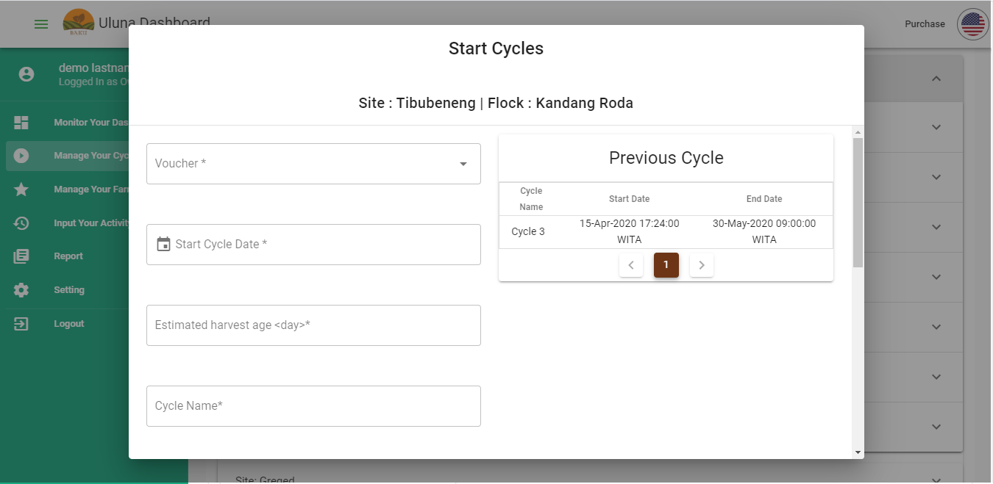

* The flock will change it’s status to “Active”

### End Cycle

After you finish a cycle you have to end the cycle. If you do not end the cycle, you will not be able to see the cycle report. Your cycle will automatically end if you did not perform the end cycle 2 weeks after estimated harvest age. If you have remaining chicken when the automatic end cycle occurs, your remaining chicken will be considered as harvested chicken with price = 0. Here are steps to end cycle:

* Open **Manage Your Cycle** menu
* Choose active flock. Click **End Cycle** button

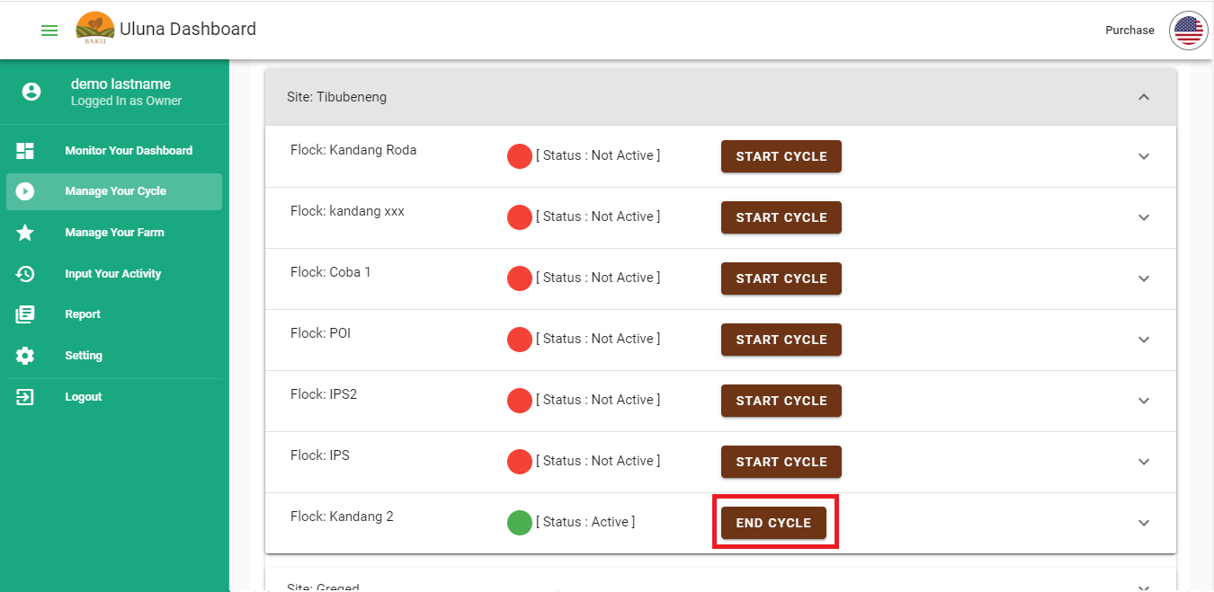

* End cycle dialogue will show. If you have a remaining chicken population, a dialog will show to confirm the status of the remaining chicken population.

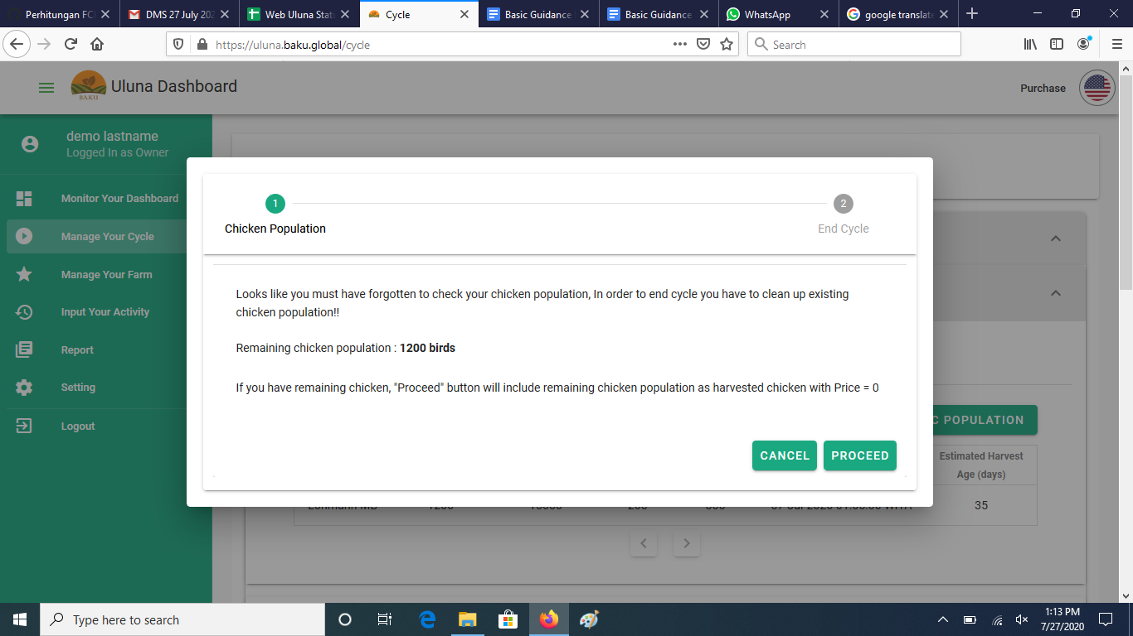

* You will be asked to input end cycle date
* Click **Submit**

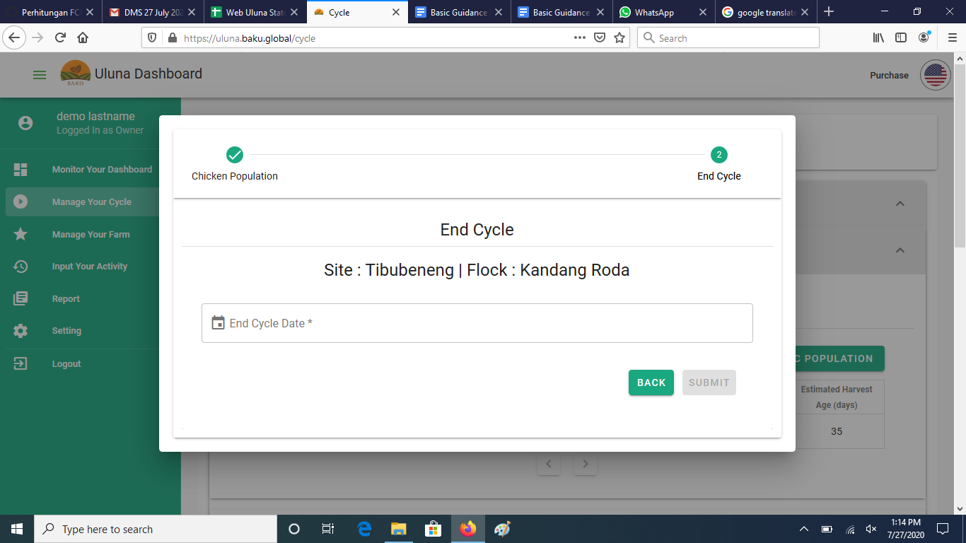

* The flock will change it’s status from “Active” to “Inactive”

### Update Population in a cycle

Sometimes there are changes when you start a cycle, such as change in DOC population. You can update DOC population after the cycle starts. Here are steps to update population in a cycle:

* Open **Manage Your Cycle** menu
* Choose active flock
* Click **Update DOC Population** button

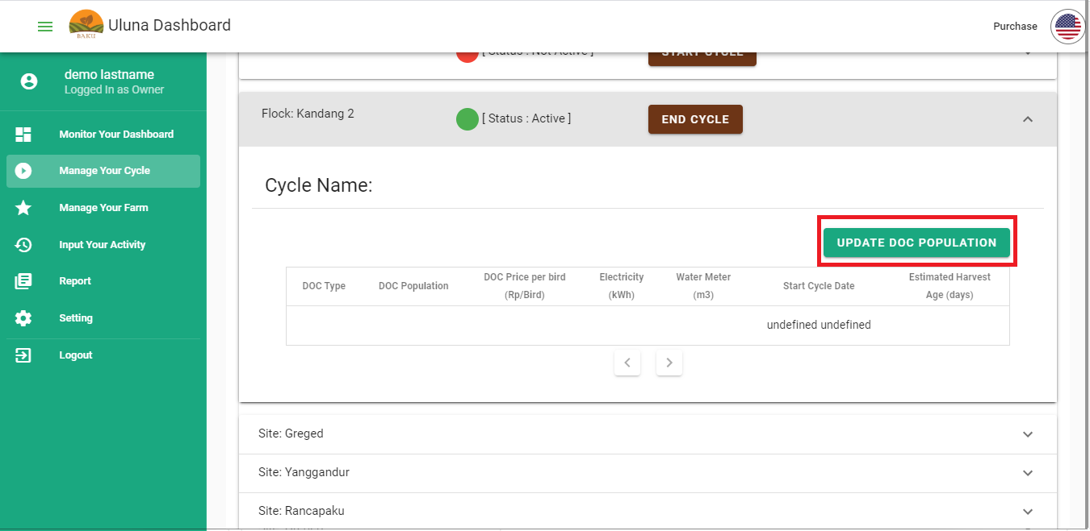

* Update DOC Population dialogue will show. You can edit population higher than the initial population (add DOC). After finish update DOC population, click **Submit**

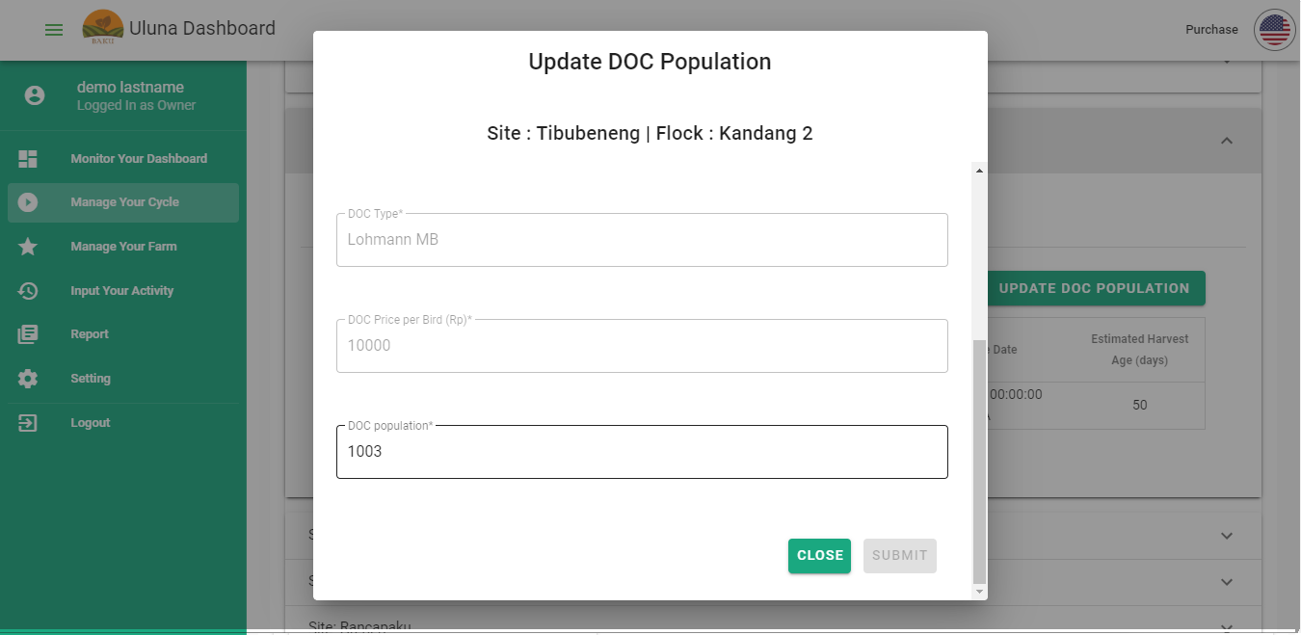

### Add Input Activity

There are some categories in Input Activity:

* Feed: record daily feed given to the flock
* Water: record daily drinking water given to the flock
* Mortality: record death chicken in a day (unit in bird)
* Average Weight: record average weight calculated every observation
* Disease: record disease along with symptoms and picture
* Litter: record litter condition every observation. Litter condition is crucial to prevent change in litter quality
* Additive (OVK): medicine, vitamin and vaccine given to chicken. You only need to record when you give additive substance to chicken
* Harvest: record harvest in a cycle

Here are how to add Input activity:

* Open **Input Your Activity** menu
* Choose the category you want to input
* Click **Add** button at the top of the table

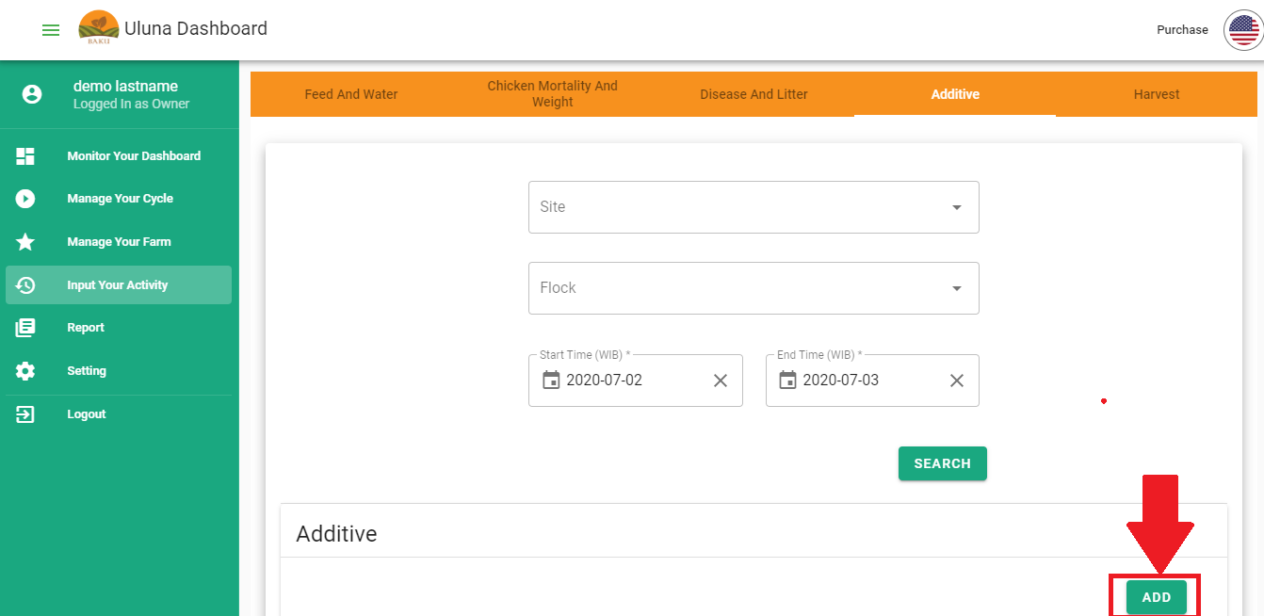

* Input dialogue will show, input all information needed then click **Submit**

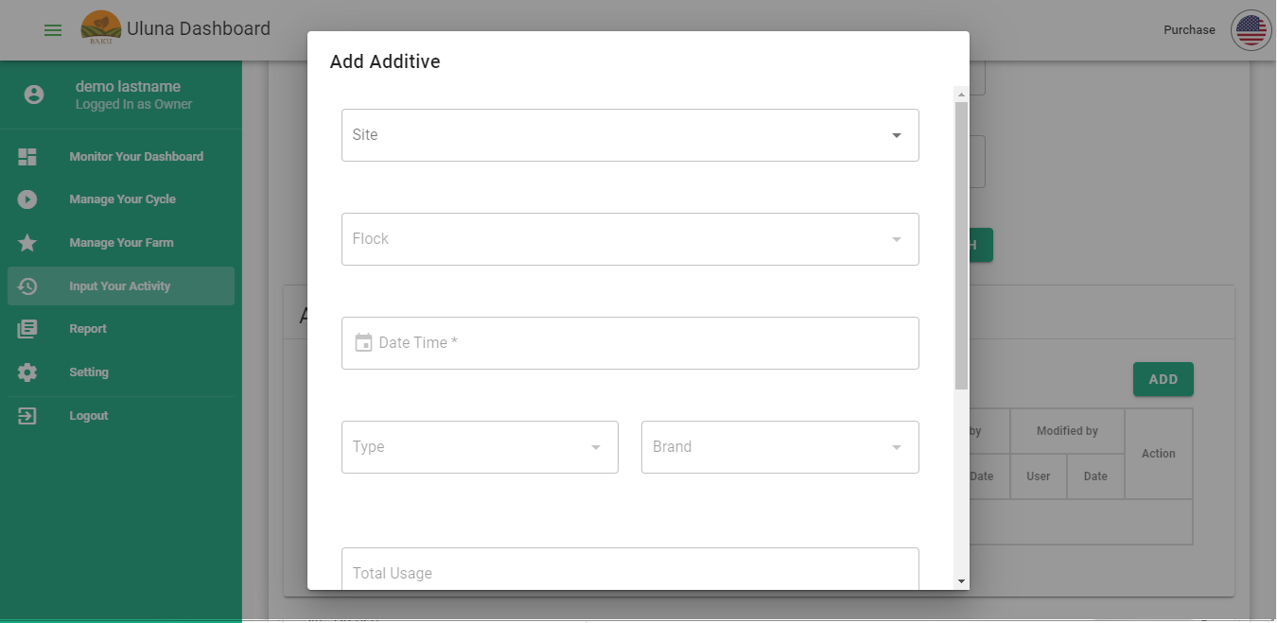

* Your input will be added to the table

### Edit Input Activity

You can update/ edit your input activity. We give you 7 days to edit your activity, after 7 days you can’t edit your input. Here are steps to edit Input Activity:

* Open **Input Your Activity** menu
* Choose the category you want to edit, find the data by using search dialogue

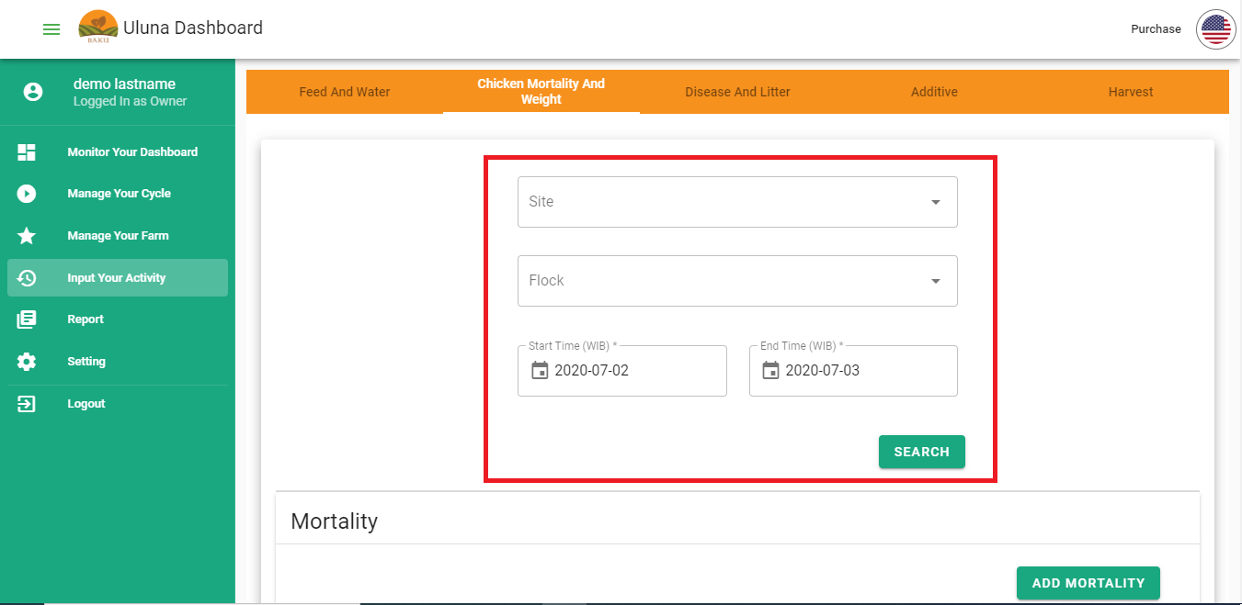

* Click pencil button (✎) at Action column

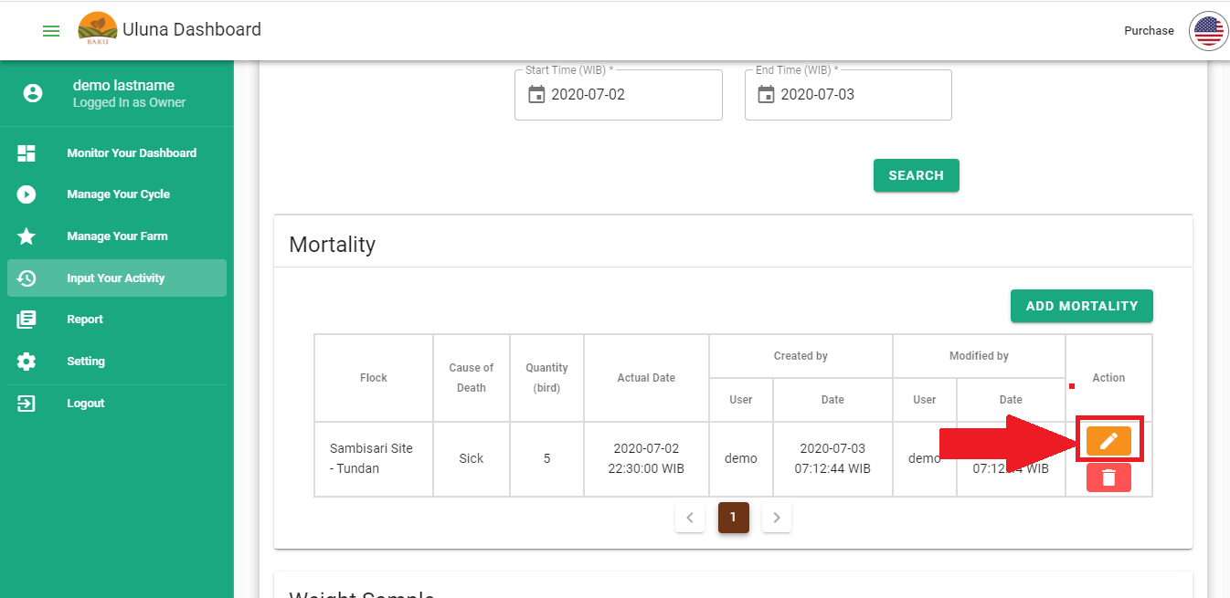

* Edit (Update) dialogue will show. You can edit input date except for Site and Flock. Click Submit

### Delete Input Activity

You can delete your input activity. We give you 7 days to delete your activity, after 7 days you can’t delete your input. Here are steps to delete Input Activity:

* Open **Input Your Activity** menu
* Choose the category, find the data by using search dialogue
* Click trash can button (🗑️) on the data that you want to delete

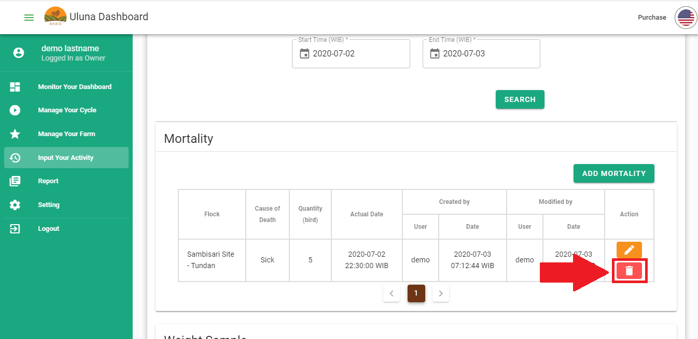

* Warning message will show, click **Yes, delete it!**

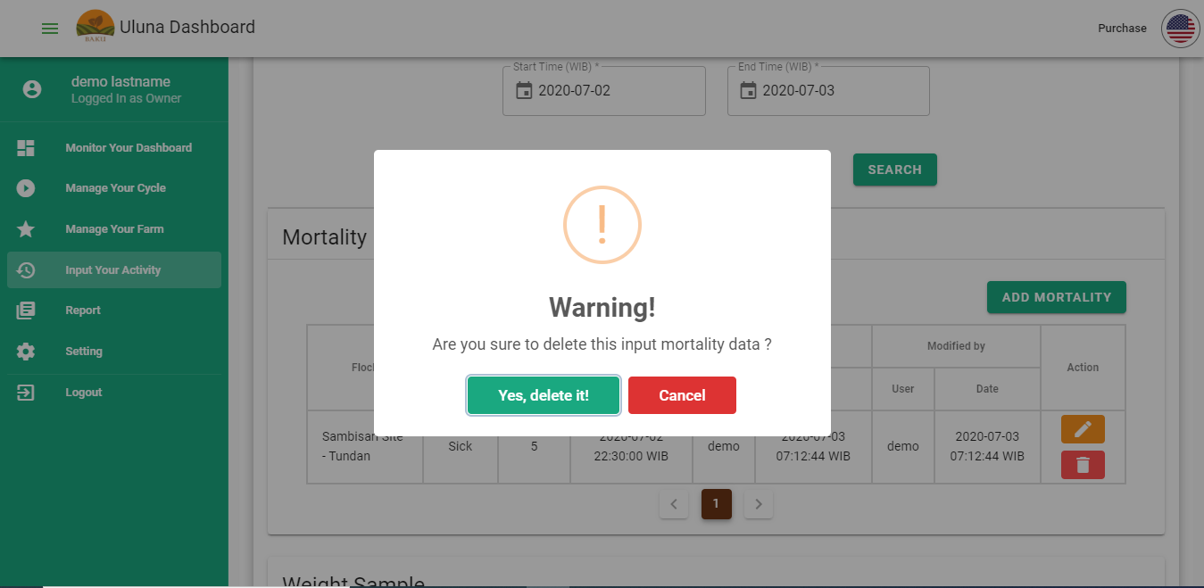

### How to add and edit Production Standard

When you input data in the Input menu, the data will be shown at the Production Cycle dashboard. Input data will be compared to Standard value. You can edit or add standard value based on performance value you want to achieve. Production standard that you can add/ update are FCR, body weight, vitality and water.

Here are steps to add/ edit Production Standard:

* Open **Settings** menu
* Click the Production **Standard** tab. List of category in production standard will show, choose one category you want to add/ edit
* Choose DOC type in the search dialogue, click **Search**
* To add new standard, click **Add** button
* Add new standard dialogue will show. Input DOC Type, period (in week) and standard value. Click **Submit**
* To edit standard value, click pencil button (✎)
* You can edit standard value in the dialogue. Click **Submit**

### How to use Dashboard

In Dashboard there are 2 tabs that you can access **Overall** and **Production Cycle**. Overall dashboard summarizes overall problems happening in your flock. Production cycle dashboard shows your input activity and compares it to standard value (based on chicken strain).

Steps to access Overall dashboard are:

* Open **Monitor Your Dashboard** menu, click **Overall** tab

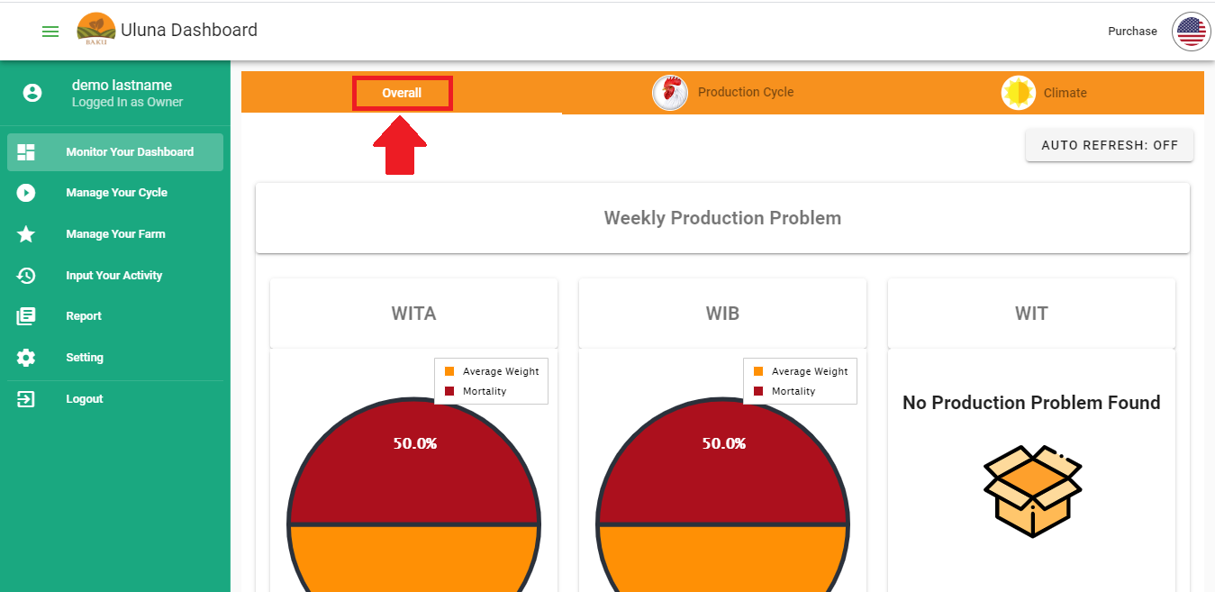

* In Overall dashboard you will see 2 charts:
  + **Weekly Performance Problem:** This chart summarizes your flock’s performance problem. You can see which flock failed to achieve the performance's goal.The chart will show you which flock has the most problems. You can also see the details by clicking flock at **Troubled flock** list.
  + **Real Time Climate Major Anomaly Frequency:** This chart summarizes all climate anomaly incidents in one day that occur from all of your flock based on local time zone. The chart will show you which flock has the most anomaly incident. You can also see the details by clicking flock at **Troubled flock** list. *This chart will not be available if you did not install a device in your flock.*

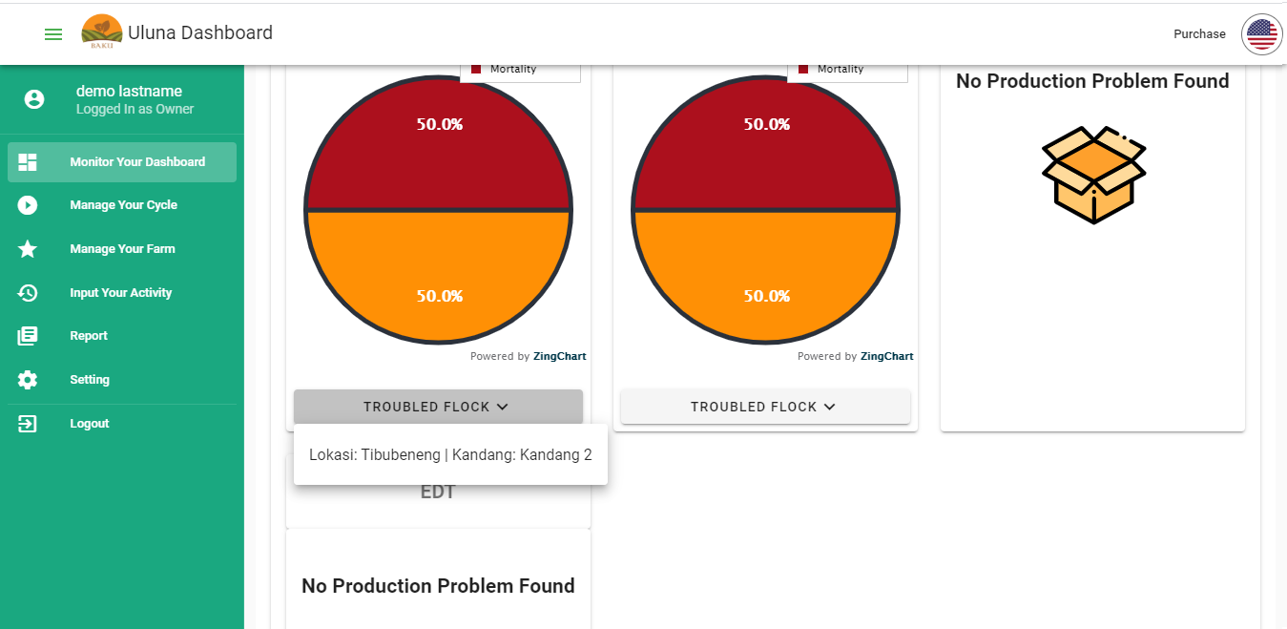

Steps to access Production cycle dashboard are:

* Open **Monitor Your Dashboard** menu, click **Production Cycle** tab
* Choose an active flock
* Under the chosen flock, you will see tables that show current condition of your chicken production (data is cumulative, from day 0 to current day). Your data will be compared to the standard based on chicken strain.

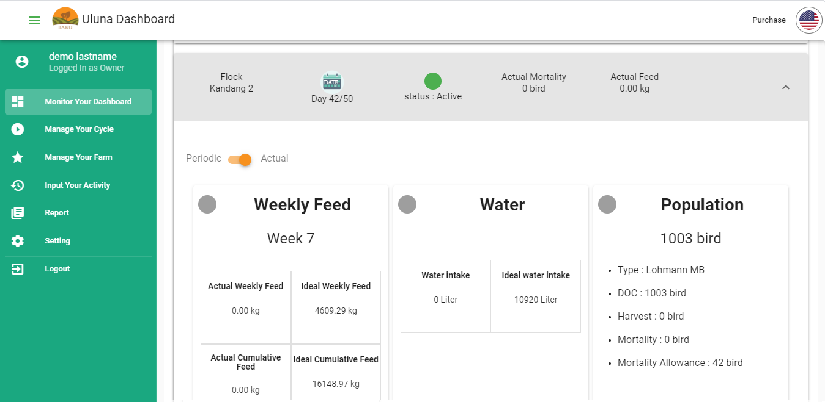

* You can also see your input summary in a week. The data will be presented in a graph. Click on **Period** button to show this data

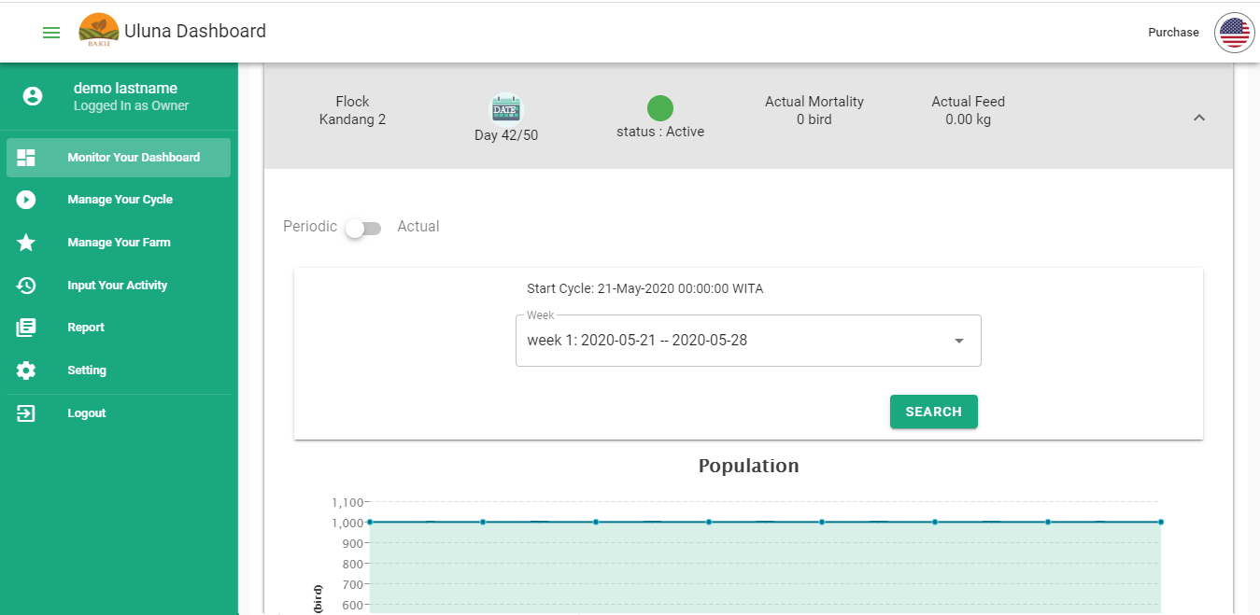

* You can search for input data from another week by searching the week on **Week** drop down then click **Search**

When you see the dashboard, you may question the source of the data. This picture compares the Production cycle dashboard interface with the Input tabs. The arrows and box shows you the source of dashboard data.

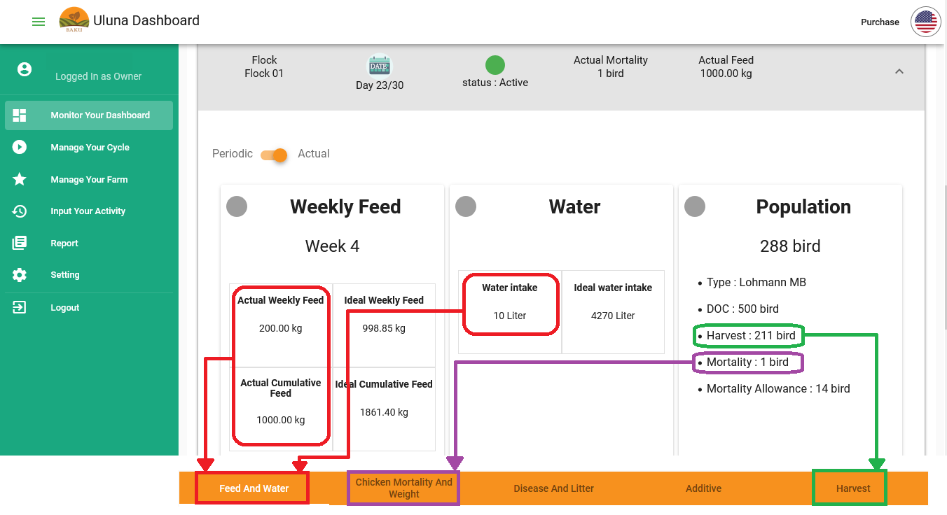

* **Weekly Feed Card**

***Actual Weekly Feed***= Total feed intake of your flock in a week. This data is calculated from your feed input in a week.

***Ideal Weekly Feed***= Feed intake standard calculated from your FCR and Body Weight standard. The value describes your flock’s feed needs in a week. You can use this value as your guidance or feed estimation. Ideal Weekly Feed calculated from feed needed to achieve Ideal FCR and Body Weight.

Example: Ideal FCR in week 2 is 0.65 and Ideal Body Weight in week 2 is 800 gram/ bird. Ideal FCR in week 3 is 0.86 and Ideal Body Weight in week 3 is 1000 gram/ bird. Population at week 2 is 900 birds, meanwhile population at the beginning of week 3 (age of 15 days) is 880 birds. Ideal Weekly Feed for week-3 is:

Feed needs/ bird= ((0.86 * 1000) - (0.65 * 800)) = 340 gram/ bird

**Ideal Weekly Feed**= Feed needs/ bird * Population at the beginning of week 3= 340 gram/ bird * 880 bird = 299200 gram = 299.2 kg

***Actual Cumulative Feed***= Total feed intake of your flock from day-0 to current date. This data is calculated from your feed input.

***Ideal Cumulative Feed***= Feed intake standard calculated from your FCR and Body Weight standard. The value describes your flock’s feed needs from day-0 to current date. You can use this value as your guidance or feed estimation. Ideal Cumulative Feed calculation:

Example: Ideal Weekly Feed at week 1 is 123 kg, meanwhile Ideal Weekly Feed at week 2 is 245 kg. Your ideal cumulative feed is:

Ideal Cumulative Feed= Ideal Weekly Feed Week 1 + Ideal Weekly Feed 2 = 123 kg + 245 kg = 368 kg

* **Water Card**

***Water intake***= Total water intake of your flock that you input in the water input menu.

***Ideal water intake***= Water intake standard based on Water Standard. You can use this value as parameter whether chickens are over drinking or drink less

* **Population card**

***Population***= current chicken population inside your flock. Population decreases because of harvest or mortality and harvest. The formula is:

Population= DOC - Harvest - Mortality

***Type***= DOC Type/ strain that you use in the cycle. This data obtained when you Start Cycle

***DOC***= DOC population you input when you start a cycle

***Harvest***= total harvested chicken calculated from your harvest input.

***Mortality***= total chicken’s death because of sickness and quality issue. Mortality data calculated from your mortality input

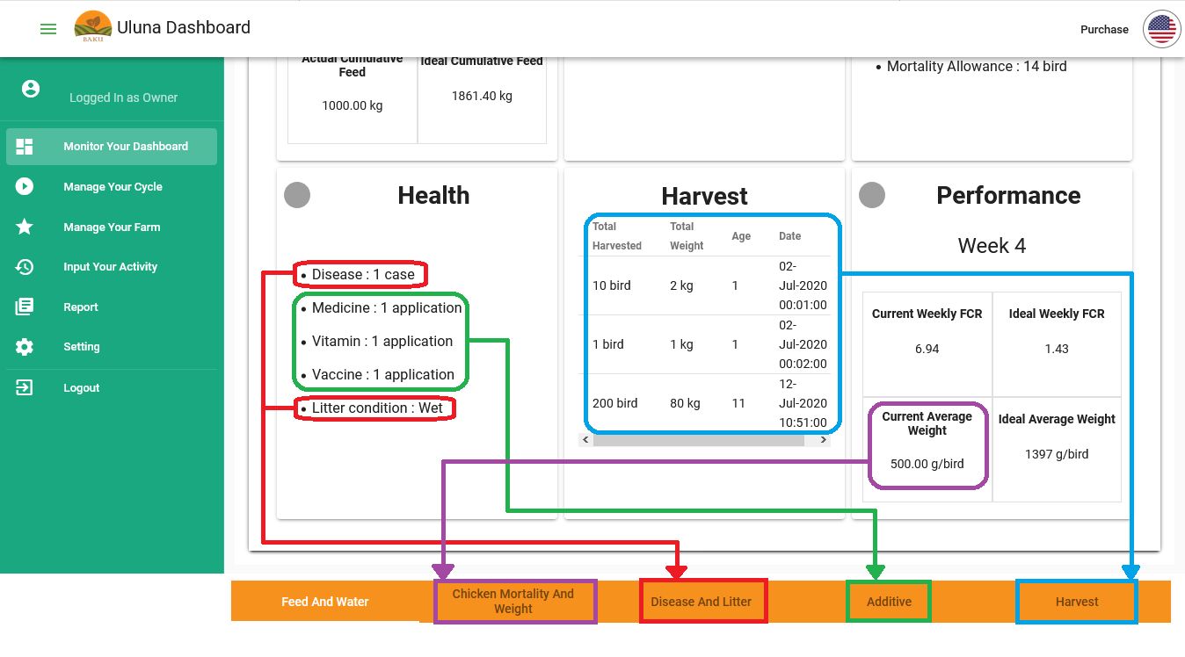

* **Health Card**

***Disease***= total disease incident based on disease input

***Medicine, Vitamin and Vaccine***= total Medicine, Vitamin and Vaccine used calculated from your Additive input

***Litter condition***= your latest litter condition. Litter condition can change based on your litter input.

* **Harvest Card**

Data from harvest input

* **Performance Card**

Performance card shows your flock’s performance based on the most commonly used parameters (FCR and Average Weight). Your flock performance is also compared to the ideal value that you set when you start the cycle (FCR and Body Weight). You will be able to evaluate your flock's current performance to the ideal condition you planned to achieve.

Performance parameter explained below:

***Current Weekly FCR*:** feed conversion ratio (FCR) of your actual input. The less FCR you have, the better performance you achieve. The formula is:

**Current Weekly FCR= Actual Cumulative Feed/ (Total harvest weight + (Average weight * Population))**

*Case example:* You start a cycle with 5000 birds of DOC strain COBB. After 28 days, you add 4500 kg of feed, your chicken average weight is 950 gram/ bird. At the age of 27 days you harvested 200 chickens with total weight 150 kg and you experience 5 dead chickens. Your current weekly FCR is:

FCR= (1200 x 1000 gram)/ ((150 x 1000 gram) + (950 gram x (5000 - 200 - 5)) = 0.96

***Ideal Weekly FCR*:** feed conversion ratio (FCR) your flock should achieve. If your Current Weekly FCR is higher than Ideal Weekly FCR, your flock may perform poorly. Ideal weekly FCR is calculated weekly, so you may experience undervalued or overvalued Current Weekly FCR at the beginning of the week. You can evaluate your flock performance by comparing current and ideal value of FCR.

***Current Average Weight*:** Chicken weight sampled from your flock. Average weight calculated from your weight input. The formula is: Average Weight= Total Sample Weight/ Number of Sample

***Ideal Average Weight*:** ideal chicken weight you set at setting menu. You can evaluate your flock performance by comparing Current Average Weight to Ideal Average Weight. You will be able to understand whether your flock is underweight or overweight.

### How to Generate Report

There are 3 reports available:

* Cycle Report: shows report from finished cycle
* Interval Report: shows report within period of time
* Input By Type Report: shows report based on type in input

#### How to generate Cycle Report

Here are steps to generate cycle report:

* First of all, you have to make sure that you already end the cycle before accessing the cycle report. Cycle report will not show if the cycle is still running
* Open **Reports** menu, click Cycle Report tab
* Input category you want to access (for free trial and basic subscription you can only access Production category)
* Input Site, Flock, and cycle
* Click **Search**

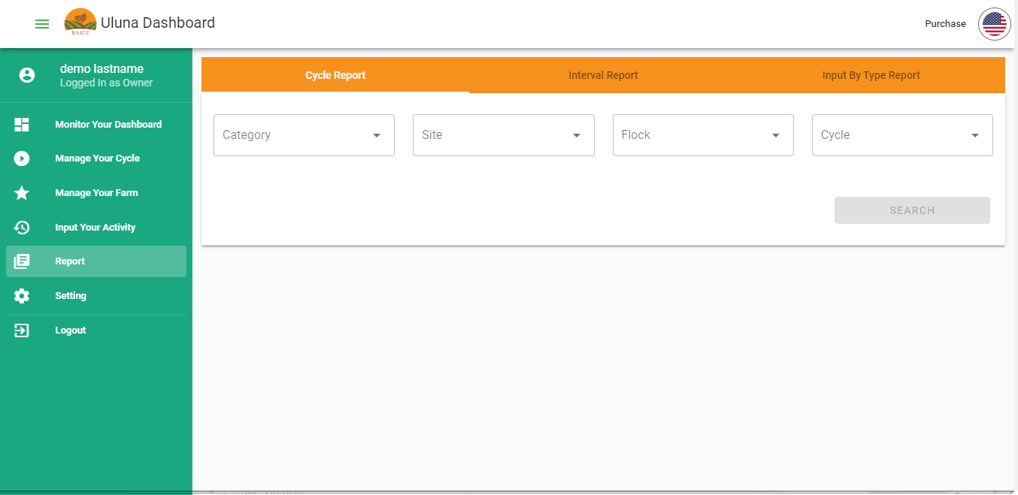

* Here are example of cycle report. You can also export/ download report into PDF file by clicking **Export Report** button

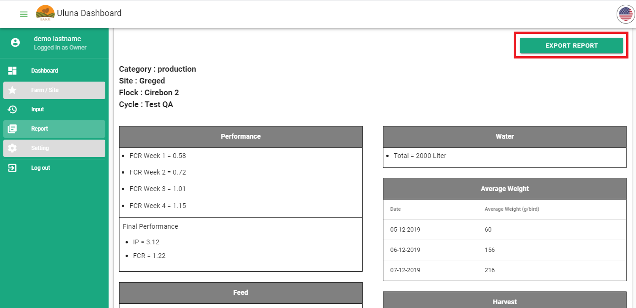

#### How to generate Interval Report

Here are steps to generate Interval report:

* Open **Reports** menu, click Interval Report tab
* Input category you want to access (for free trial and basic subscription you can only access Production category)
* Input Site, Flock, and time interval (**Start Time** and **End Time**)
* Click **Search**

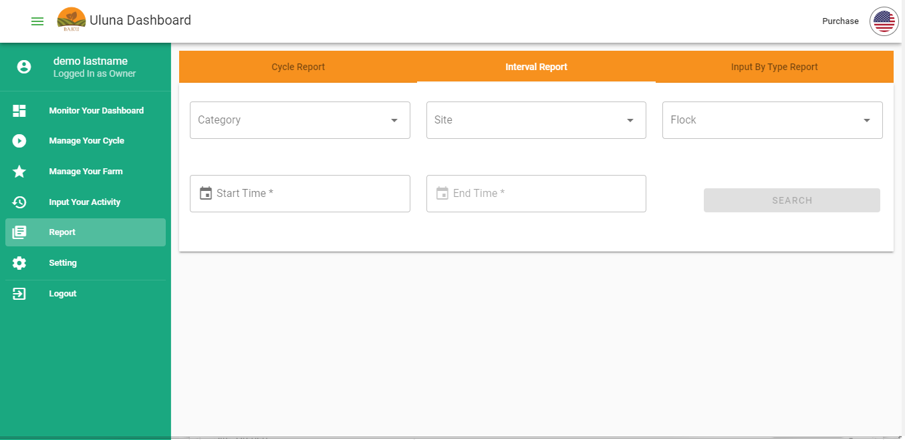

#### How to generate Input by Type Report

Here are steps to generate Input by Type report:

* Open **Reports** menu, click Input by Type Report tab
* Input category you want to access. There are categories you can access: feed, mortality, additive and disease
* Input Site, Flock, and time interval (**Start Time** and **End Time**)
* Input Type
* Click **Search**

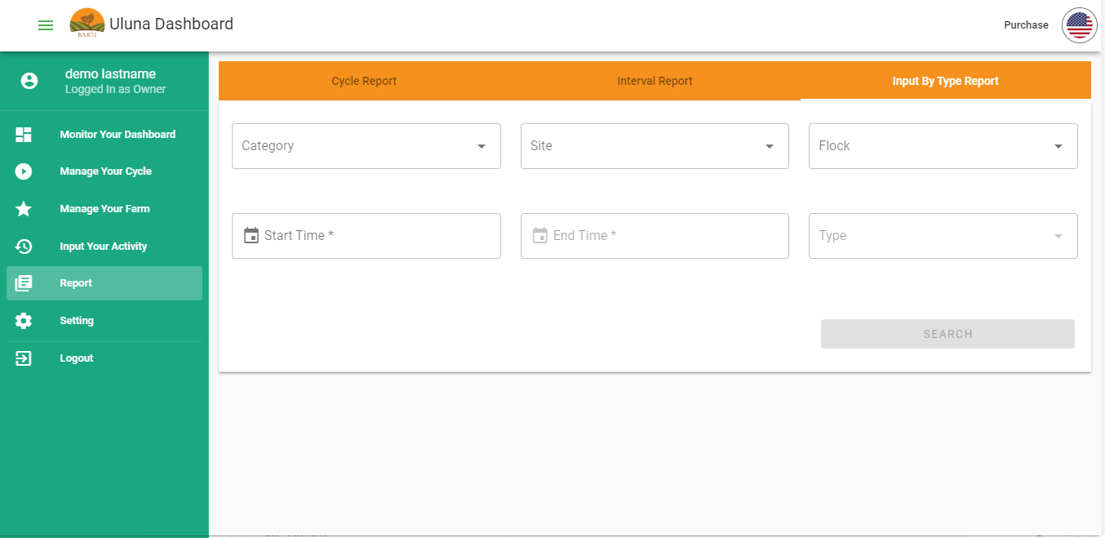

### Notifications

Urgent information that you need to know immediately will be sent via email and sms. Here are notifications that you will receive:

* Harvest Day: 3 days before harvest you will be reminded to prepare your harvest by email and sms notification. Harvest day calculated from **Estimated Harvest Age** that you input at start cycle.
* Average Weight: We will inform you if your chicken average weight has reached targeted weight as you wish (average weight target calculated from strain and estimated harvest age). Notification will be sent via email.
* Weekly Production Report: we will summarize data that you input on **Input Your Activity**. This report will be sent via email.

### How to purchase Voucher

Voucher is required to start a cycle, without a voucher you will not be able to use Baku’s feature. When you create your account you will receive 1 free trial voucher. This voucher is applicable for 40 days in a cycle. After this voucher is used, you have to purchase another voucher in order to start a cycle. Here are steps to purchase voucher:

* Open **Purchase** menu located on top right of the page, beside the language button

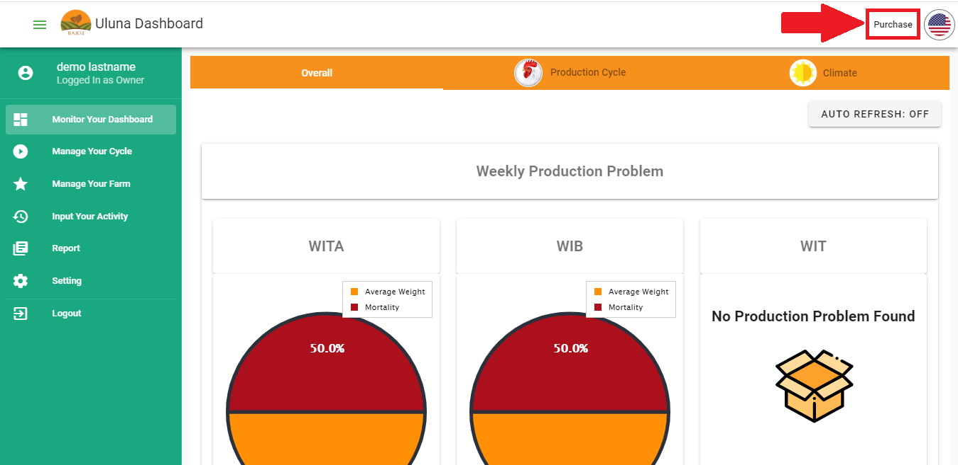

* Click **Purchase Voucher** tab
* Choose voucher you want to purchase, click **Buy Voucher** button

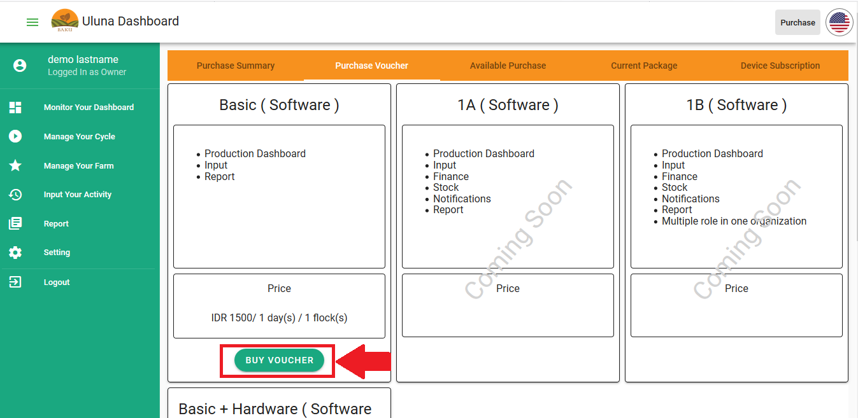

* Buy voucher dialogue will open. Input voucher quantity and use period. **Total Price** will automatically be calculated
* Choose payment method you want to use, click **Continue Payment**

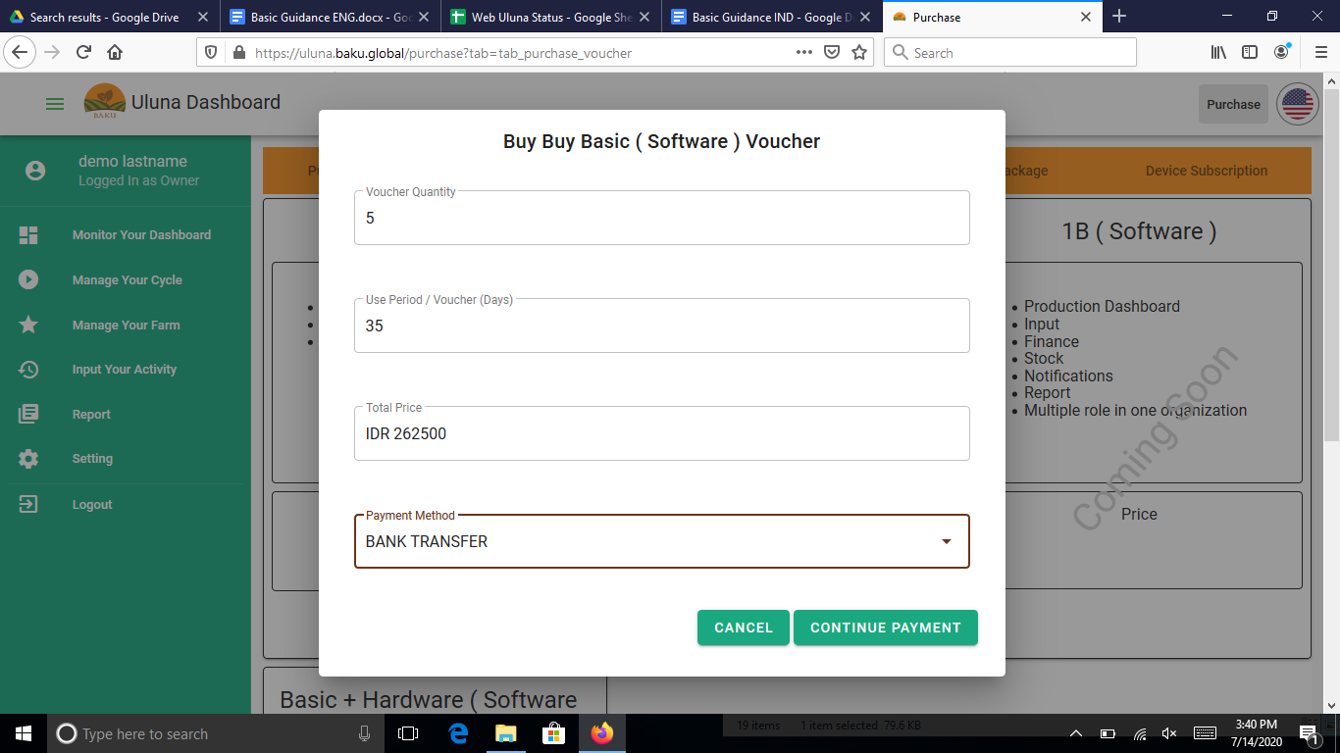

* Confirmation dialogue will show, click **Yes, Submit it!** button
* Purchase summary will show with it’s Order ID and payment method

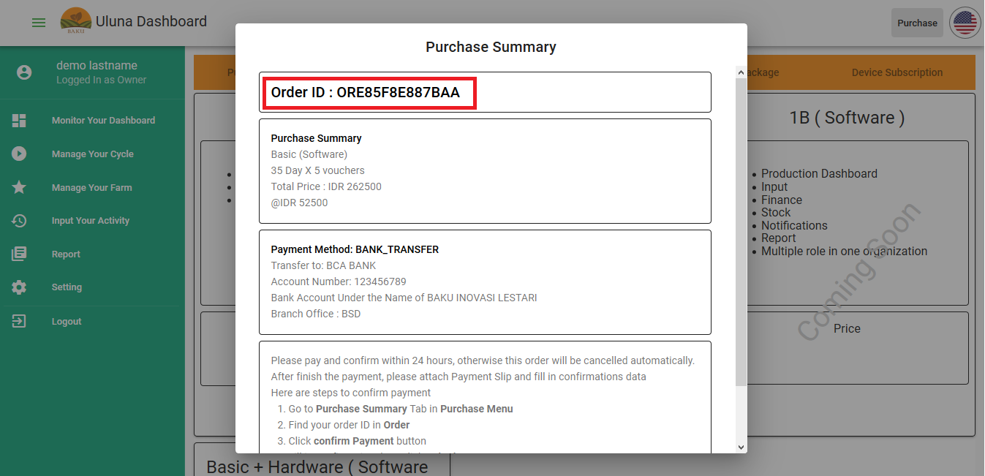

* Complete payment within 24 hours. After 24 hours, the order will expire. Don’t forget to keep payment slip
* Confirm payment after you finish payment. If you don’t confirm your payment, your payment will be considered not valid and your voucher will not be published.

### How to confirm payment

Here are steps to confirm payment:

* Open **Purchase** menu located on top right of the page, beside the language button
* Click **Purchase Summary** tab
* Find your Order ID in the Purchase History table. You can use filters to search your order ID

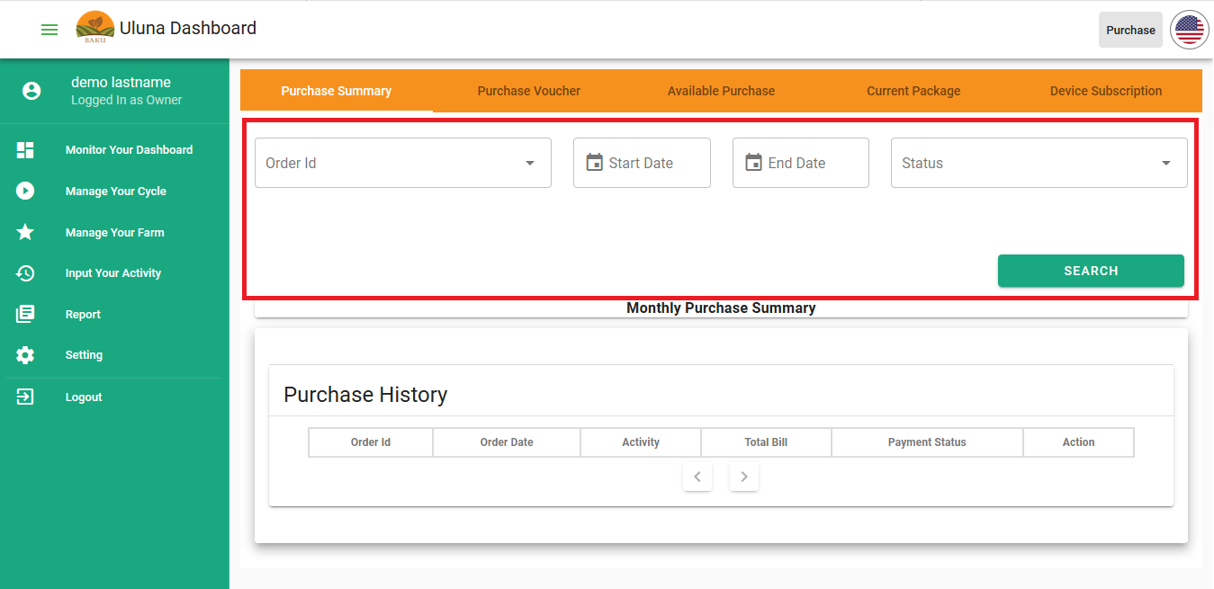

* After you find your Order ID, click **Confirm Payment** button

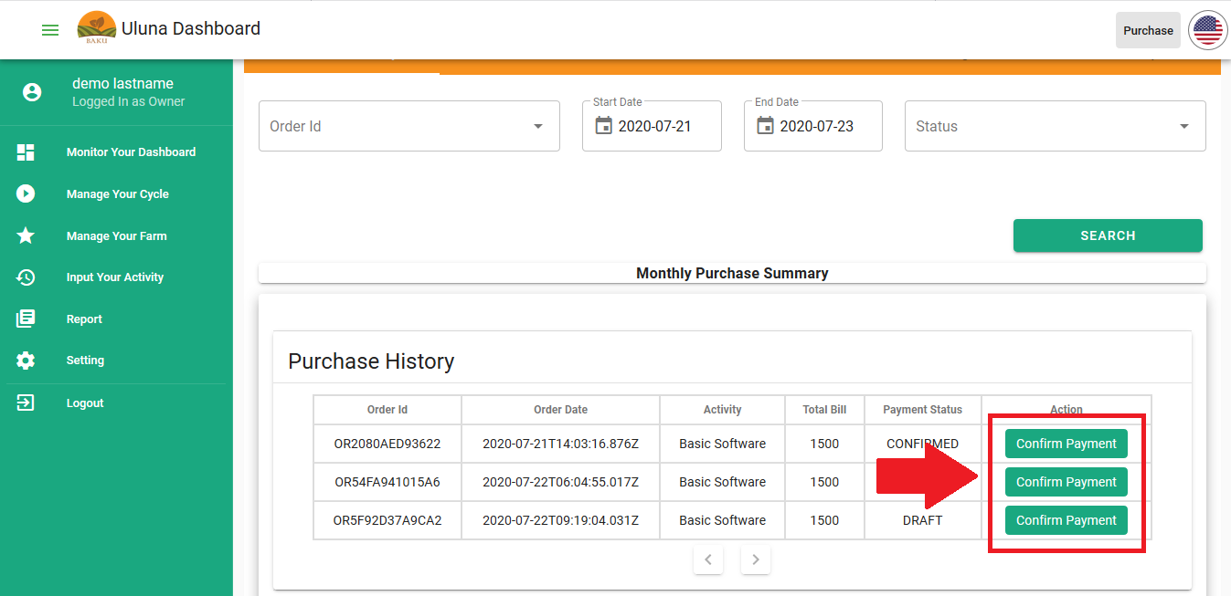

* Input all the data required, click **Submit**

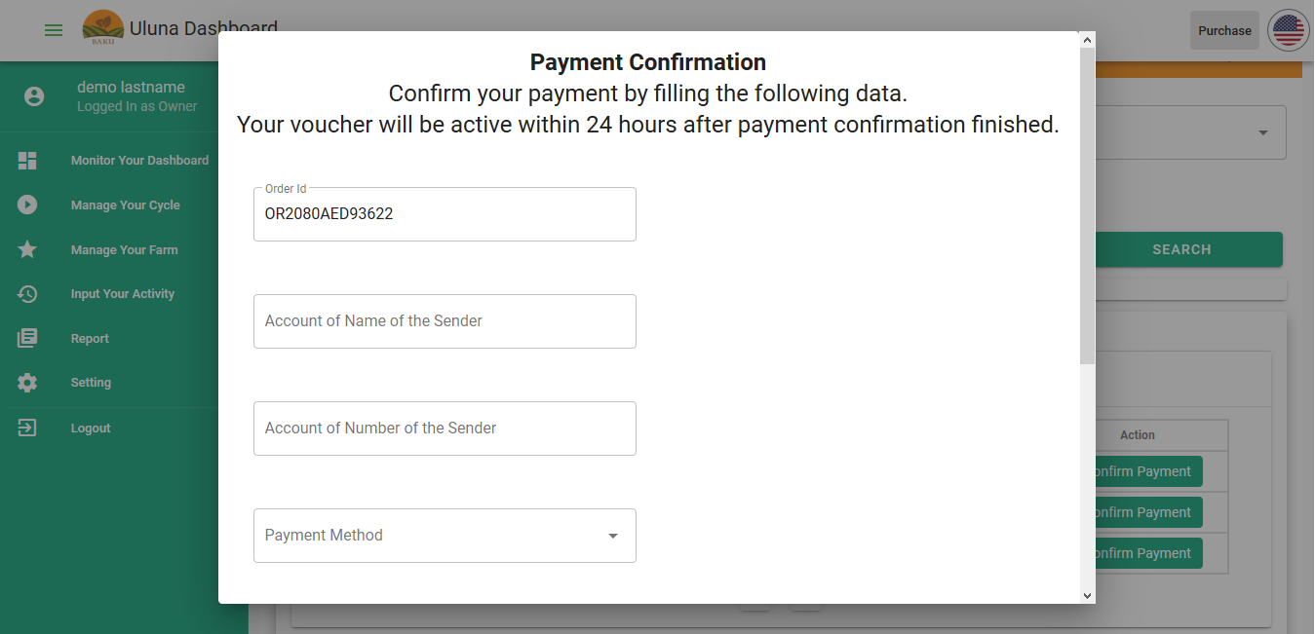

* Voucher will be generated within 24 hours after payment confirmation is sent. Your voucher will be shown at the voucher list at Start Cycle dialogue. Your voucher will be sent via email.